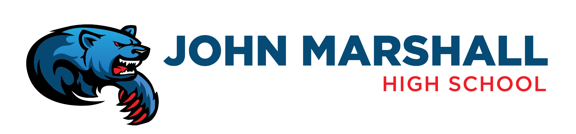
JOHN MARSHALL MID-HIGH ENTERPRISE SCHOOL
TITLE I FAMILY-SCHOOL COMPACT
2021-2022
Administrative Responsibilities:
o Create a collaborative environment with teachers, parents, students and community
members
o Provide instructional leadership and ensure best practices regarding academic strategies
o Provide a safe and orderly learning environment
o Provide research-based, updated, individualized professional development for HQ staff
o Maintain open, transparent communication with all stakeholders
o Respect school property, students, staff and parents
Teacher Responsibilities:
o Work collaboratively with parents to ensure student success
o Motivate students with relevant standards-based activities
o Provide a safe, orderly classroom environment
o Participate in professional growth activities
o Establish open communication with parents/guardians
o Build appropriate, positive relationships with students
o Respect school property, colleagues, parents and students

Parent/Guardian Responsibilities:
o Work collaboratively with administrators and teachers to ensure student success
o Actively participate in the school community
o Assist with students with school-related activities and projects
o Maintain open communication with teachers and administrators
o Respect the school, administrators and teachers

Student Responsibilities:
o Work collaboratively with administrators, teachers and other students to ensure
academic success
o Be involved with school activities
o Participate in classroom learning activities and virtual learning
o Attend tutoring and Saturday School in order to stay caught up in all classes
o Communicate needs with teachers, parents and administrators
o Help ensure a safe learning environment for all students
o Take ownership of learning
o Respect school property, peers, teachers, parents, and administrators

